Tyler Fung

Professor Steven Walters

ESS 420 A - Intro to GIS: Earth Sciences

04 November 2019

Measuring Runoff that Affect the Bogachiel River Salmon

The Bogachiel River system lies in the state of Washington of the Olympic Peninsula. The river flows through both Clallam and Jefferson County. It starts at the Bogachiel Peak where it flows west through Olympic National Park. The river then joins into the Sol Duc River forming the Quilayute River which then flows out to the Pacific Ocean near La Push Washington (Clallam County, n.d.). The Bogachiel valley was once covered in glaciers known as the Vashon glacier. The time of the collapse of the Vashon glacier in the Bogachiel valley is unknown but the disappearance of the glacier occurred about 6500 Before Present (BP) based on radiocarbon dates from the river bogs and pollen assemblages (Heusser, 1973). The river can be accessed to the public on foot or by boat near the U.S. 101 Bridge, Bogachiel Fish Hatchery, and Three Rivers where people can enjoy recreational activities such as steelhead fishing. The Bogachiel River also provides exceptional spawning and rearing habitats for spring, summer, and fall Chinook, coho, chum salmon, and winter steelhead (Clallam County, n.d.).

In Washington, salmon and steelhead are managed by the state of Washington and Indian tribes whose rights were instituted in treaties signed with the federal government. In exchange of continuing Indian tribes traditions such as the right to fish and gather shellfish the Indians allowed a peaceful settlement of much of western Washington to the government. Two public management processes are involved in salmon management. One is the Pacific fishery Management Council and the second the North of Falcon. The Pacific Fishery Management Council sets annual fisheries in federal waters while the North of Falcon sets salmon fishing season in inland waters. The state and tribes have been attempting to restore salmon stocks due to the loss and degradation of estuarine and freshwater habitats (Salmon and Steelhead Co-Management).

Salmon are culturally and economically important to many native tribes and since salmon habitats, are declining resulting in reduced salmon populations; our group project aims to find factors that may affect salmon abundance in the Bogachiel River Valley. Our project will focus on the Quileute native tribe since they have jurisdiction with the Quillayute River and the 4 subbasins: the Dickey, Sol Duc, Calawah, and Bogachiel River. The Quileute native tribe has founded that salmon production is limited due to altered estuaries and armored banks from increased sedimentation, water flow, reduced rating ofs of large woody debris, and loss of hydrologic maturity. The main reason for this is human exploitation of natural resources in the area as well as invasive knotweed (Quileute-StateOfOurWatershed.pdf). Our group will reconstruct findings from the *Northwest Indian Fisheries Commission* using data we have found. Using multiple datasets from different websites we attempt to conclude the same findings. I will analyze terrestrial runoff into the Bogachiel River while my colleague Bernabe Ibarra analyzes water quality of the Bogachiel River using the software Arcmap. In Arcmap, I will analyze where there are high soil erosion rates in the Bogachiel River, high potential runoff from roads, high runoff from agricultural lands, and high runoff from residential lands in the Clallam and Jefferson County that might flow into the Bogachiel River. High runoff from these factors can potentially increase sedimentation in the Bogachiel River so it is imperative to address these areas and determine the best management practice to mitigate runoff since it can harm salmonoids. My colleague will assess……….

Methods: Description of Data sets

The base data source was the Light Gray Canvas in Arcmap “Add Basemap”. I added this map to the soil erosion analysis because it acts as a locator map where it shows were the Bogachiel River is located relative to a broader context of Washington and the cities around the river.

For the elevation layer I used the Washington 10-meter Data. It is a Digital Elevation Model (DEM) displaying the elevation for the state of Washington. The specific zip file is called mosaicked zone-10 data and is a public-domain data from the USGS. The format is a raster with cell size of 10, 10, meters, pixel type as an unsigned integer, pixel depth of 16 Bit, linear units in meters, and angular units in degrees. The coordinate system is in NAD_1927_UTM_Zone_10N (*10-Meter Data,* 2012).

From the Clallam County website I used the parcel data. We both used the roads data set. The parcel data set was a polygon vector which displays land ownership boundaries. Each parcel is identified by a 12 digit parcel number that is unique and each is defined by historical taxing precedent (Clallam County, Washington, 2019). The road data set were vector lines. It displays all roads and highways in Clallam County, and some of Jefferson County that are part of the 911 addressing system. It does not include private driveways, forest roads, and alleys (Clallam County, Washington, 2019). Both of these data sets were in the projection NAD_1983_HARN_StatePlane_Washington_North_FIPS_4601_Feet. The projection for both the roads and parcel data was changed using the project tool to the DEM projection of NAD_1927_UTM_Zone_10N.

A data set in vector polygon format of public parcels in the Jefferson County was used in my analysis. The projection was in GCS_WGS_1984 so it was converted using the project tool to the DEM projection of NAD_1927_UTM_Zone_10N. The layer represents real property areas; combine with tax information from CAMA and Tax systems (Public Parcels, 2019). The Jefferson road layer was not used in the data set since the Clallam roads layer had the necessary roads that were near the Bogachiel River system.

For Washington statewide data sets, fish distribution, and soils data set were used in both our analysis. Both data sets were obtained from the Washington DNR open data website. The fish distribution layer are vector lines of the rivers and in the attribute table describes what fish are in that stream, lake, etc. The coordinate system was GCS_WGS_1984 and converted to NAD_1927_UTM_Zone_10N using the project tool. The soils layer also had the same projection and was converted to NAD_1927_UTM_Zone_10N using the project tool. The fish distribution layer is a single National Hydrography Dataset combining data from Northwest Indian Fisheries and the Washington Department of Fish and Wildlife. It includes species of anadromous as well as residents (Statewide Washington Integrated Fish Distribution, 2018). The WA soils layer was a vector polygon. It was derived from the Private Forest Land Grading system and soil surveys. Private lands having potential of supporting commercial forests were surveyed with small areas of state lands, Indian tribal lands, and federal lands (WA Soils, 2019).

Lastly, watershed boundary of the Bogachiel River system was derived from the USGS watershed website as a TNM download. The hydrologic unit 8 was used since it contained the Bogachiel River in a single polygon. It is a vector polygon with the coordinate system of GCS_North_American_1983. It was then projected to the DEM projection of NAD_1927_UTM_Zone_10N (USGS The National Map, n.d.).

Methods: Description of Analysis

From the Washington fish distribution data set I used the select by attributes to specify fish species only in the Bogachiel River. I then converted this to its own layer naming it as the Bogachiel River fish distribution. Since the vector was a line shape I used a buffer of 10 feet to make the Bogachiel River fish distribution a polygon. This was done to do further analysis that require vectors to not be line shape. To determine soil properties of the Bogachiel River, Bogachiel River fish distribution layer with the Washington soil layer was intersected. From the new intersected layer I used the select by attributes feature and used the expression SOIL_EROSI = ‘HIGH’. This determined where soil erosion is marked as “high” which means sedimentation would most likely occur. I then made this feature into its own layer called “High soil erosion”. Determining the soil in the Bogachiel River is important since soil erosion will occur due to the flow of the river and may cause sedimentation if the soil is too loose. This can be confirmed by determining the soil texture which is the size of the soil particles of small (clay), medium (silt), and large (sand). The soils most likely to cause significant erosion are silt particles (Ball, 2001).This affects salmon abundance since they require clean oxygenated gravels to spawn. During the winter the salmonid eggs laid in gravels must have water passing through and space around the gravel to breathe. If not, the eggs can become suffocated or smothered due to soil erosion and run-off (Soil & Salmon: Keeping Soil on the Land to Save Our Salmon, n.d.). The soil in the area can determine if the major vegetation is suitable in that area. If not, then different vegetation may be needed to bind soil together, infuse the soil with organic matter, make the soil resistant to runoff, and filter sediment more efficiently (Soil Erosion and Sedimentation, n.d.).

Using the select by attributes for the parcel layer for Clallam County residential layers were only selected and separated into its own layer using the column “LU_Desc”. Residential areas for Clallam County included 1100 - Residential- Single Unit, 1300 - Multi Unit Apartments, 1900 - Cabins, Park Models, RV Utilities, etc. The Jefferson county layer was also separated into residential using the select by attributes of the column LUDESC_RES to each category. This was then separated into its own layer. The residential layer for both Clallam and Jefferson County were then merged together to form a layer of residential parcels in the Jefferson and Clallam County. The content for both layers were preserved since they were merged. To determine agricultural parcels in the Clallam county and Jefferson county select by attribute was used for the parcels for each county and then separated into their own layers. Specifically for the parcels in Clallam County, the column LUDESC_OTH was used and specified for agriculture. For Jefferson County, the LU_DESC column was used to isolate areas that contained agricultural in their name. The layers for Clallam county and Jefferson county were then merged into one layer preserving the data for each county.

For the Watershed Hydrologic Unit 8 layer, a select by attribute was used to narrow the watershed to just the Bogachiel River system. The name of the watershed was called Hoh-Quillayute. This was then converted to its own layer. The DEM of Washington was clipped to the Hoh-Quillayute watershed layer to narrow the DEM to just the watershed.

To determine runoff for roads, parcels of agricultural, and residential parcels flow accumulation will need to be calculated for each layer. First, the DEM layer of the watershed boundary will be converted to a depressionless DEM. Then the depressionless DEM will be adjusted for flow direction and then into flow accumulation. A zonal statistics and zonal statistics as table was then applied for the roads layer to the flow accumulation DEM where the sum was calculated to calculate the total value of all cells from the flow accumulation DEM that belong to the roads layers name field. The runoff from roads leads to an increase of sedimentation that can harm salmon. Oils from cars can be transported to the river affecting the water quality, heavy metals can make it toxic for the salmon to breathe clogging their gills, and if there are road salts this can produce significant sodium and chloride which can kill the salmons (Runoff: Surface and Overland Water Runoff, n.d.). A zonal statistics and zonal statistics as table was also applied to the agricultural and residential parcel layers separately to the flow accumulation DEM. Since both layers were merged, the zone field will be the new Object ID that was formed when they merged. Knowing the residential and agricultural lands is significant since nitrogen and phosphorous lawn and crop fertilizers can leach into the soil and contaminate the rivers after intense precipitation decreasing water quality which may decrease the abundance of salmon in the river (Land Use and Water Quality, n.d.). This can degrade the water quality of the river making it difficult for the salmon since sedimentation provides less visibility making it difficult for smolts to capture food when they travel downstream (Surface Runoff and the Water Cycle, n.d.).

My colleague Barnaby Ibarra, looked at salmon health, car traffic pollution potential, and how passage point effects salmon spawning. This is just a summary and not in depth description of his analysis. Please see his report for an in depth description. In the Fish - Salmon Health Index he looked at the Bogachiel River as a whole watershed system. He selected segments of the fish were present, rearing, or spawning. He then selected factors based on soil quality. The implication is an estimate of riparian conditions which encourage or discourage the thriving of salmon fish in those streams.

In his roads - Car Traffic Pollution Potential he looked at potential reach of pollutants. The assumptions is rubber tires pollute the roads along with stormwater runoff and watershed systems so streams were implemented into his project. To weigh the roads he buffered the AADT point based on traffic frequency and then merged with the roads buffer of 100 meters on each side. He then used multiple buffering to illustrate effective reach (in graduated purple). His table shows the count of streams affected by the traffic.

In the fish passage - Passage Point Effects On Salmon Spawning - layers grouping he began by clipping the roads to the Bogachiel watersheds. The fish passage inventory are points where fish are known to cross - culverts, fishways, or bridges - and its those fish passage points are categorized as either corrected, uncorrected, and planned to correct. All these points and layers were clipped to the bounds of the Bogachiel watersheds. The fish passage points represent the status of the fish passage and spawn potential. He interpolated his result which creates a geostatistical layer of the z attribute effect between all points. The implications is uncorrected fish passages with the greatest impact on fish/salmon spawning should be corrected to increase the health or increase abundance of fish/salmon.

Results and Discussion:

Based on the high soil erosion map (Figure 1), high soil erosion is highlighted in yellow. Based on the table (Table 1), salmon species that were found were spring, summer, fall Chinook (spawning), chum (spawning), and Coho salmon (presence). Other fish species that were also there were cuthroat trout and steelhead trout. The soil in that area had a soil parent material of glacial outwash, soil texture of gravelly loam, and the soil title Klone series. Major vegetation in the area were Western Hemlock with 108 species counted (Table 1). The parent material of glacial outwash suggest that the Vashon Glaciation played a role in the soil that was formed there now. Glacial outwash qualities in general have a flat layers of sand and other sediments (Schaetzl, n.d.). Specifically, in the high soil erosion in the Bogachiel River the soil series Klone have poorly sorted glacial outwash (KLONE SERIES, n.d.). This was confirmed in the soil rocks with a 40-60 percent which means that soil texture has significant amounts of sand and silt. This could potentially be one reason why there is a high soil erosion in that area. The tree species western hemlock, prefer soil that have average depth from 4.5 inches on soils with good drainage to 43.2 cm. This is consistent with the data since average soil depth was greater than 60 inches and the soil drainage was well drained. On the coast, western hemlock develops best between sea rating of and 610 m (2,000 feet). This is also consistent with the soil elevation ranging which ranged between 50-1200 feet (Table 1). Although the soil can cause significant soil erosion the vegetation in the area is suitable so it does not cause any additional runoff. Management should focus on the high soil erosion area to reduce the erosion so it does not lead to an increase of sedimentation. If high soil erosion persist then it can decrease abundance of chum and Chinook salmon since the eggs from spawning can become suffocated and decease from the accumulated sedimentation (Soil & Salmon: Keeping Soil on the Land to Save Our Salmon, n.d.).

The roads map of Clallam and Jefferson County of flow accumulation show that Highway 101 demonstrates the highest flow accumulation with 7981889m (Figure 2 yellow). Areas that also had fair amount of flow accumulation are Undi Road (308607m) and Dowans Creek Road (242907m) (Figure 2) (Table 2). Ratings for roads, residential, and agricultural area were based on a rating from 1-5 based on flow accumulation for each factor. 1 represent very low flow accumulation while 5 represents very high flow accumulation. Highway 101 flow accumulation (rating of 4) is significant because highway pollutants, such as solids, heavy metals, and organics (found in fuels and motor oils) have been found to correlate directly with traffic volume. Since highways are used more this suggest that there is significant runoff. High traffic volume coupled with high flow accumulation can be detrimental to the salmon in the area. General measures to reduce runoff from highways are eliminating curbs. If curbs are necessary leaving gaps instead of a continuous curb will allow air transport of pollutants from the highway. More enforcement on litter control can achieve pollutant reduction through limiting potential pollutant sources and properly minimizing deicing will provide reduction of ground and surface water contamination. Reducing runoff velocity is also important since erosive levels can increase transport of particles which encourage sedimentation. Reducing gradients, installing drop structures, baffles, and using grassed waterways can reduce runoff velocity. Establishment and maintenance of vegetation along highway rights-of-way provides pollutant-reduction and can be enhanced by establishing dense grass cover (Maestri et. al n.d.). These management strategies to reduce runoff will in turn lead to better survival rates for salmon in the area. The toxicity from oil, heavy metals, and road salts will be reduced making it easier to breathe for the salmons so they can further live and spawn in the Bogachiel River (Runoff: Surface and Overland Water Runoff, n.d.).

Flow accumulation was also displayed for residential areas near the Bogachiel River (Figure 3). There were no significant flow accumulation in the general area, but observing directly in the Bogachiel River there was significant flow accumulation (Figure 4). The highest flow accumulation based on Figure 4 was 28,059,300 meters (rating of 4) which is a single unit residential home, the next highest was 11,846,367 meters which is a mobile home with land (rating of 3), and 4,648,440 which could be cabins, park models, or R.V. utilities (rating of2) (Table 3) (Figure 4) . Other areas directly affecting flow accumulation were fairly low. Urban runoff generally contains heavy metals and petroleum hydrocarbons from motor vehicles. Residential areas at these locations should make sure they can reduce as much runoff as possible. Notifying these areas might also help prevent significant runoff since these places might not even know that flow accumulation is significant where they live. Residents can make sure not to dump things down storm drains, recycle used oil, antifreeze and other fluids. They can also wash their cars at car wash stations or make sure to wash their vehicle in their own lawn. They can also reduce the amount of fertilizer, pesticides, and herbicides. Finally they can plant vegetation in their areas and direct runoff to those vegetation. This will prevent as much runoff from streams as possible preventing salmon in the area to not decease by having healthy water quality for them to spawn and travel efficiently to the sea (Stormwater Runoff Pollution and How to Reduce It, 2016).

Agricultural areas in Clallam and Jefferson County showed that there were no areas directly affecting the Bogachiel River but there were agricultural areas with high flow accumulation that may indirectly affect the Bogachiel River. Starting from right to left on the graph (Figure 5) displayed in dark red the sum for the flow accumulation was 442158 which was a farm. The next was 195536 meters which was open space agriculture, and 138243 meters which was also open space agriculture (Table 4). Agricultural runoff generally contains a greater diversity of pesticides, as well as pathogens and nutrients. These areas should make sure they can reduce as much runoff and pollution since agricultural areas are large areas. Specifically, applying nutrients such as phosphorous, nitrogen, and potassium in the form of chemical fertilizers manure and sludge should use them cautiously and efficiently. Livestock grazing can expose soil to erosion and destroy vegetation and streambanks. Farmers should adjust for grazing intensity, keep livestock out of the sensitive areas, and promote revegetation of ranges, pastures and riparian zones. Notifying these areas may also be a suggestions as well since they might not know the area accumulates high flow rates. Theses management practices saves them money by being efficient and reduce runoff that could affect the vegetation in their area. Preserving the vegetation in the area is important to salmon since plant species retain nutrients from the soil and prevent runoff by reducing the amount of chemicals that might drain into the streams (Protecting Water Quality from Agricultural Runoff, 2005).

My colleague Barnaby Ibarra

Overall, our results showed similar results to the Quileute native tribe. We also found salmon production is limited due to increased sedimentation, water flow, and loss of hydrologic maturity due to human exploitation in the Bogachiel River. There were significant flow accumulation affecting the Bogachiel River based on roads and residential areas. There was also high soil erosion area in the river itself. Indirectly, there were agricultural areas that contained high flow accumulation. These high flow accumulation have the potential to have runoff that can be detrimental to the water quality affecting salmon abundance in the Bogachiel River specifically spring, summer, fall Chinook (spawning), chum (spawning), and Coho salmon (presence). The high soil erosion in the Bogachiel River could potentially be due to the Klone soil series since they have soil rocks of 40-60 percent which can starve the salmon traveling to the sea since visibility will be lowered affecting how much prey they can find. If salmon are not big enough at sea they could be eaten by other fish or not return since there are more predators (orcas, sharks, etc.). Major vegetation at the high soil erosion area was consistent with the type of soil it needs to flourish (western hemlock) so it does not cause any additional runoff. Highway 101 had a high flow accumulation of 7981889m. Residential areas had 3 directly high flow accumulation in the Bogachiel River with 28,059,300 meters (rating of 4) 11,846,367 meters (rating of 3), and 4,648,440 (rating of2). Agricultural areas had areas of high flow accumulation although they were relatively far but can still affect the Bogachiel River indirectly.

Salmon are culturally and economically important to many native tribes. Salmon are affected by runoff since runoff affects the quality of the water that they are swimming. High soil erosion can cause sedimentation if the soil is too loose affecting the visibility of the salmon to go out to sea. Eggs laid by the salmon when they spawn must be in gravels that have water passing through and space around the gravel to breathe. If not, the eggs can become suffocated or smothered due to soil erosion and run-off (Soil & Salmon: Keeping Soil on the Land to Save Our Salmon, n.d.). Oils from cars can be transported to the river affecting the water quality, heavy metals can make it toxic for the salmon to breathe clogging their gills, and if there are road salts this can produce significant sodium and chloride which can kill the salmons (Runoff: Surface and Overland Water Runoff, n.d.). Residential and agricultural lands can cause significant nitrogen and phosphorous that leach into the soil and contaminate rivers after intense precipitation decreasing water quality of water bodies (Land Use and Water Quality, n.d.). Salmon species was only one species we accounted for but there are many other species affected by runoff. Careful management strategies on artificial structures should be implemented to areas of high flow accumulation and high erosion. One potential management strategy is to increase awareness to the public especially ones with high flow accumulation.

References Cited

Ball, Jeff. “Soil and Water Relationships.” *Noble Research Institute*, <https://www.noble.org/news/publications/ag-news-and-views/2001/september/soil-and-water-relationships/>.

“Clallam County, Washington.” *Map Data*, 11 Nov. 2019 <http://www.clallam.net/Maps/mapdata.html>.

Heusser, Calvin J. *Age and Environment of Allochthonous Peat Clasts from the Bogachiel River Valley , Washington*. no. March, 1973, pp. 797–804.

“KLONE SERIES.” Official Series Description - KLONE Series, soilseries.sc.egov.usda.gov/OSD_Docs/K/KLONE.html.

“Land Use and Water Quality.” *Water Encyclopedia*, [http://www.waterencyclopedia.com/La-Mi/Land-Use-and-Water- Quality.html#ixzz66DyLzSwe](http://www.waterencyclopedia.com/La-Mi/Land-Use-and-Water-%09Quality.html#ixzz66DyLzSwe).

Maestri, Bruno, et al. “Managing Pollution from Highway Storm Water Runoff .” *TRANSPORTATION RESEARCH RECORD 1166* , pp. 15–21., doi:http://onlinepubs.trb.org/Onlinepubs/trr/1988/1166/1166-003.pdf.

Protecting Water Quality from Agricultural Runoff, Mar. 2005, [www.epa.gov/sites/production/files/2015-](http://www.epa.gov/sites/production/files/2015-) 09/documents/ag_runoff_fact_sheet.pdf.

“Public Parcels.”*Open Data Portal*, 11 Nov. 2019https://gisdata- jeffcowa.opendata.arcgis.com/datasets/public-parcels?geometry=- 127.027,47.133,-121.858,48.425.

*Runoff: Surface and Overland Water Runoff*, <https://www.usgs.gov/special-topic/water-science-school/science/runoff-surface-and-overland-water-runoff?qt-science_center_objects=0#qt-science_center_objects>.

“Salmon and Steelhead Co-Management.” *Washington Department of Fish & Wildlife*, <https://wdfw.wa.gov/fishing/tribal/co-management>.

Schaetzl, Randall. Outwash Plains, geo.msu.edu/extra/geogmich/outwash_plains.html.

“Soil & Salmon: Keeping Soil on the Land to Save Our Salmon.” *Westcountry Rivers Trust*, <https://wrt.org.uk/soil-salmon-keeping-soil-on-the-land-to-save-our-> salmon/.

“Soil Erosion and Sedimentation.” *Huron River Watershed Council*, <https://www.hrwc.org/our-watershed/threats/soil-erosion-sedimentation/>.

“Statewide Washington Integrated Fish Distribution.” *Washington State Geospatial Open Data Portal*, 21 May. 2018 <http://geo.wa.gov/datasets/4ed1382bad264555b018cc8c934f1c01_0?geometry>= -123.752,47.224,-123.106,47.387&selectedAttribute=DISTTYPE_DESC.

“Stormwater Runoff Pollution and How to Reduce It.” *Stormwater Runoff Pollution and How to Reduce It - King County*, 25 July 2016, [www.kingcounty.gov/services/environment/water-and-land/stormwater/introduction/stormwater-runoff.aspx](http://www.kingcounty.gov/services/environment/water-and-land/stormwater/introduction/stormwater-runoff.aspx).

*Surface Runoff and the Water Cycle*, <https://www.usgs.gov/special-topic/water-science-school/science/surface-runoff-and-water-cycle?qt-science_center_objects=0#qt-science_cerunonter_objects>.

“USGS The National Map.” *TNM Download*, viewer.nationalmap.gov/basic/?basemap=b1&category=nhd&title=NHD%2BView#productSearch.

“WA Soils.” *Data*, 16 July. 2019 [http://data-wadnr.opendata.arcgis.com/datasets/wa-soils?geometry=- 121.083,47.164,-120.920,47.184](http://data-wadnr.opendata.arcgis.com/datasets/wa-soils?geometry=-%09121.083,47.164,-120.920,47.184).

*10-Meter Data*, 21 Dec. 2012, gis.ess.washington.edu/data/raster/tenmeter/.

Tyler’s Maps:

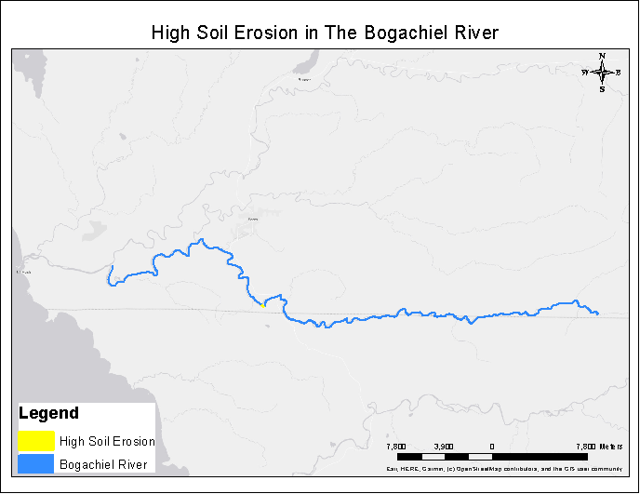Figure 1: Overall view of the Bogachiel River (blue) where soil erosion is considered high (yellow).

|  |  |  |  |  |  |  |  |  |  |
| --- | --- | --- | --- | --- | --- | --- | --- | --- | --- |
| SPECIESRUN | USETYPE_DE | SOIL_TITL_ | SOIL_ELEV | SOIL_TXTR_ | SOIL_ROCK_ | SOIL_DPT | SOIL_DRAIN | MAJ_TREE_S | MAJ_SPEC_S |
| Spring Chinook | Spawning | KLONE | 50 - 1200 feet | V.GRAVELLY LOAM | 40 - 60 % | >60 inches | WELL Drained | Western Hemlock | 108 |
| Resident Coastal Cutthroat | Presence | KLONE | 50 - 1200 feet | V.GRAVELLY LOAM | 40 - 60 % | >60 inches | WELL Drained | Western Hemlock | 108 |
| Summer Chinook | Spawning | KLONE | 50 - 1200 feet | V.GRAVELLY LOAM | 40 - 60 % | >60 inches | WELL Drained | Western Hemlock | 108 |
| Fall Chum | Spawning | KLONE | 50 - 1200 feet | V.GRAVELLY LOAM | 40 - 60 % | >60 inches | WELL Drained | Western Hemlock | 108 |
| Winter Steelhead | Spawning | KLONE | 50 - 1200 feet | V.GRAVELLY LOAM | 40 - 60 % | >60 inches | WELL Drained | Western Hemlock | 108 |
| Coho | Presence | KLONE | 50 - 1200 feet | V.GRAVELLY LOAM | 40 - 60 % | >60 inches | WELL Drained | Western Hemlock | 108 |
| Fall Chinook | Spawning | KLONE | 50 - 1200 feet | V.GRAVELLY LOAM | 40 - 60 % | >60 inches | WELL Drained | Western Hemlock | 108 |
| Summer Steelhead | Presence | KLONE | 50 - 1200 feet | V.GRAVELLY LOAM | 40 - 60 % | >60 inches | WELL Drained | Western Hemlock | 108 |

Table 1: Based on Figure 1 characteristics of the high soil erosion area of fish, soil, and vegetation.

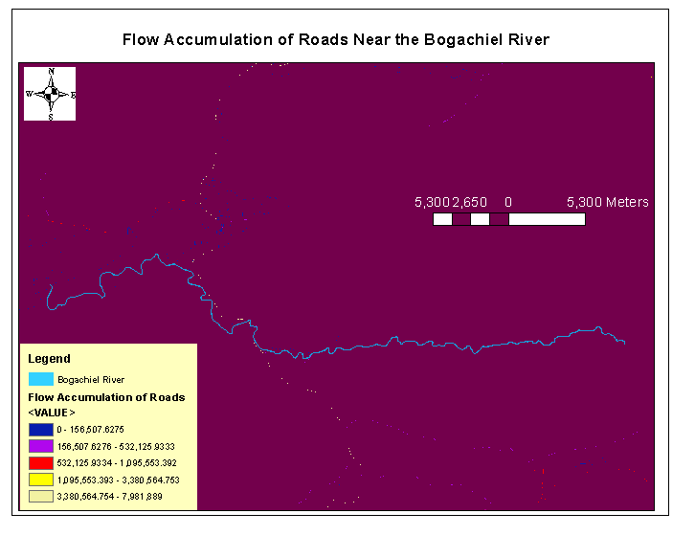Figure 2: Flow accumulation of roads in Clallam and Jefferson County that can lead to potential runoff into the Bogachiel River.

|  |  |  |  |
| --- | --- | --- | --- |
| MAPNAME | Flow Accumulation (Meters) | Rating (1-5) (Low-High Flow Accumulation) | Color |
| Hwy 101 | 7981889 | 4 | Yellow |
| Undi Rd | 308607 | 2 | Light Blue (Near Hwy 101) |
| Dowans Creek Rd | 242907 | 2 | Light Blue |

Table 2: Characteristics of Figure 2 of flow accumulation of roads. Hwy 101 as the highest rating indicated in yellow.

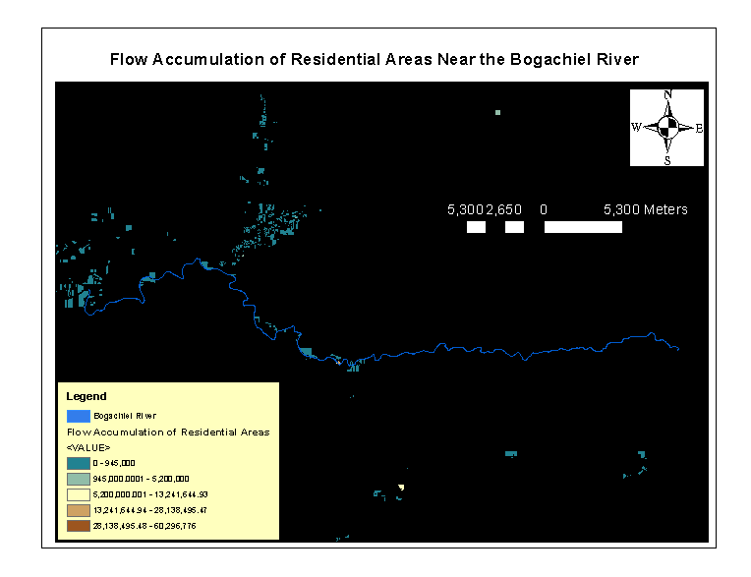Figure 3: Overall view of the residential areas in Clallam and Jefferson County based on flow accumulation.

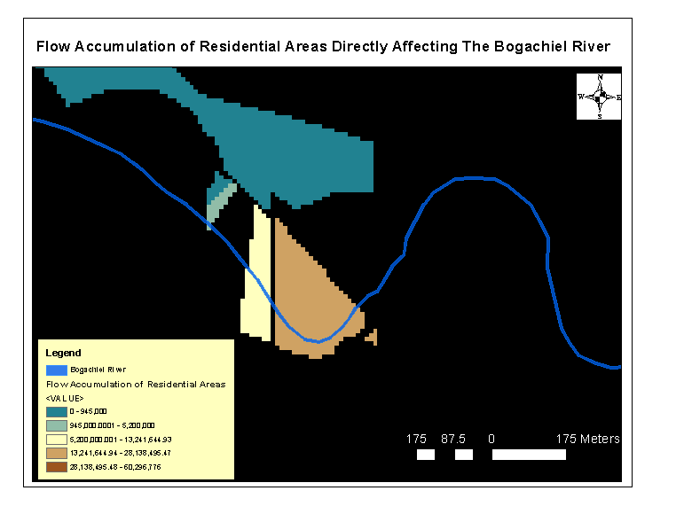Figure 4: Areas with high flow accumulation that are directly affecting the Bogachiel River with potential of direct runoff into the river.

|  |  |  |
| --- | --- | --- |
| Resident Description | Flow Accumulation (Meters) | Rating (1-5)(low-high Flow Accumulation) |
| 1100 - Residential - Single Unit | 28059300 | 4 |
| 1101 - Residential - MH W/Land | 11846367 | 3 |
| 1900 - Cabins, Park Models, RV Utilities | 4648440 | 2 |

Table 3: Description of residential areas that have high flow accumulation (Figure 4) that directly affect the Bogachiel River leading to direct runoff. Rating of low flow accumulation (1) was not accounted.

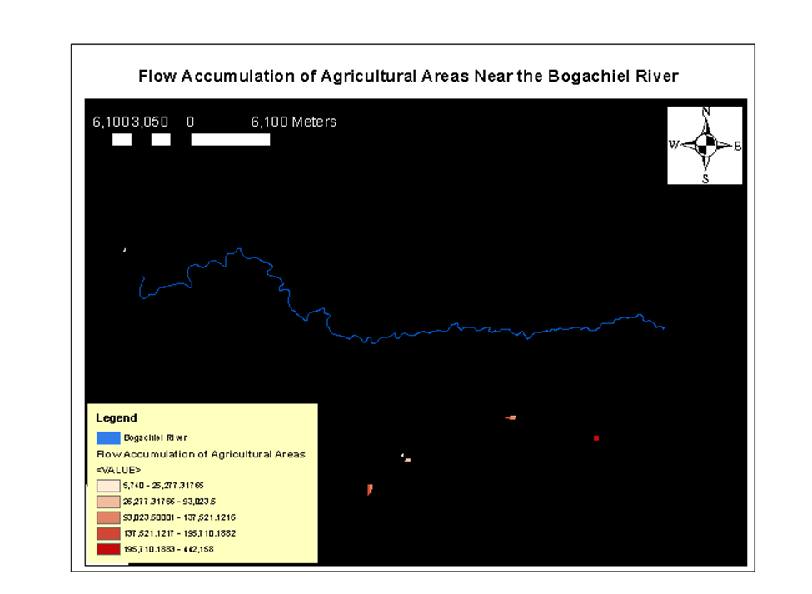

Figure 5: Agricultural areas near the Bogachiel River including farms.

|  |  |  |
| --- | --- | --- |
| Description of Area | Flow Accumulation (Meters) | Rating (1-5) Flow Accumulation |
| 8000 - Farms | 442158 | 4 |
| 8300 - Open Space Agricultural (A) | 195536 | 3 |
| 8300 - Open Space Agricultural (A) | 138243 | 3 |

Table 4: High flow accumulation of agricultural areas with description of each area. Rating of 4 (farms) is on the lower right with the other description starting right of the farms.

Bernabe's Maps:

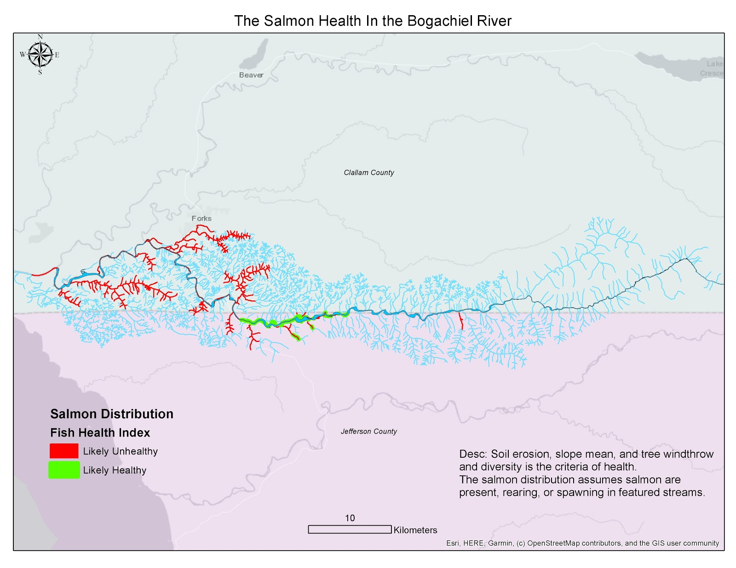

Map 1: Illustrates the likely health index of salmon habitats in streams

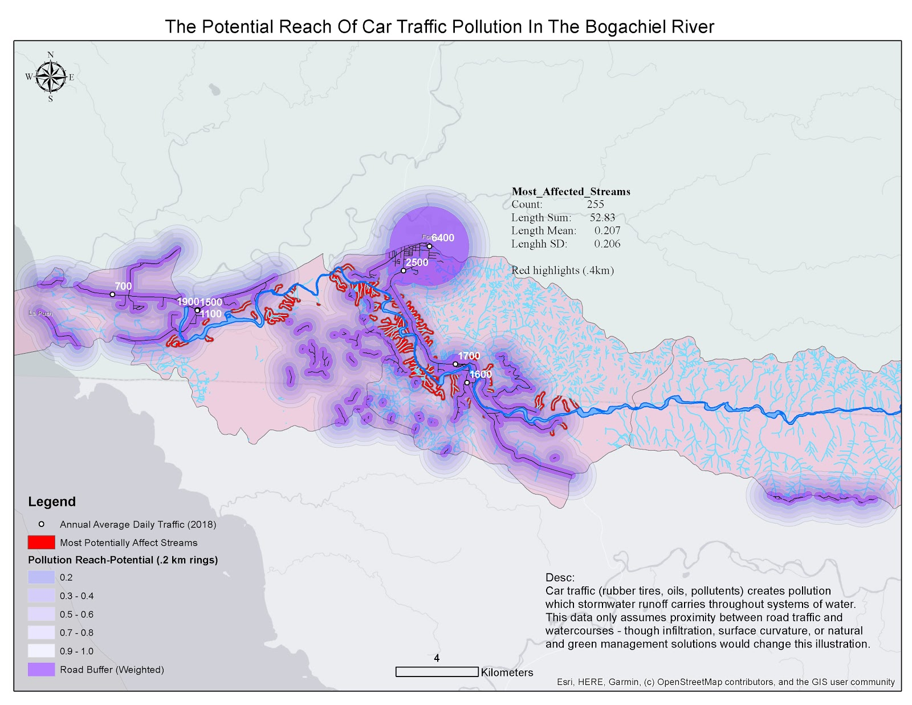

Map 2: Illustrates the likely reach of traffic pollution of salmon streams

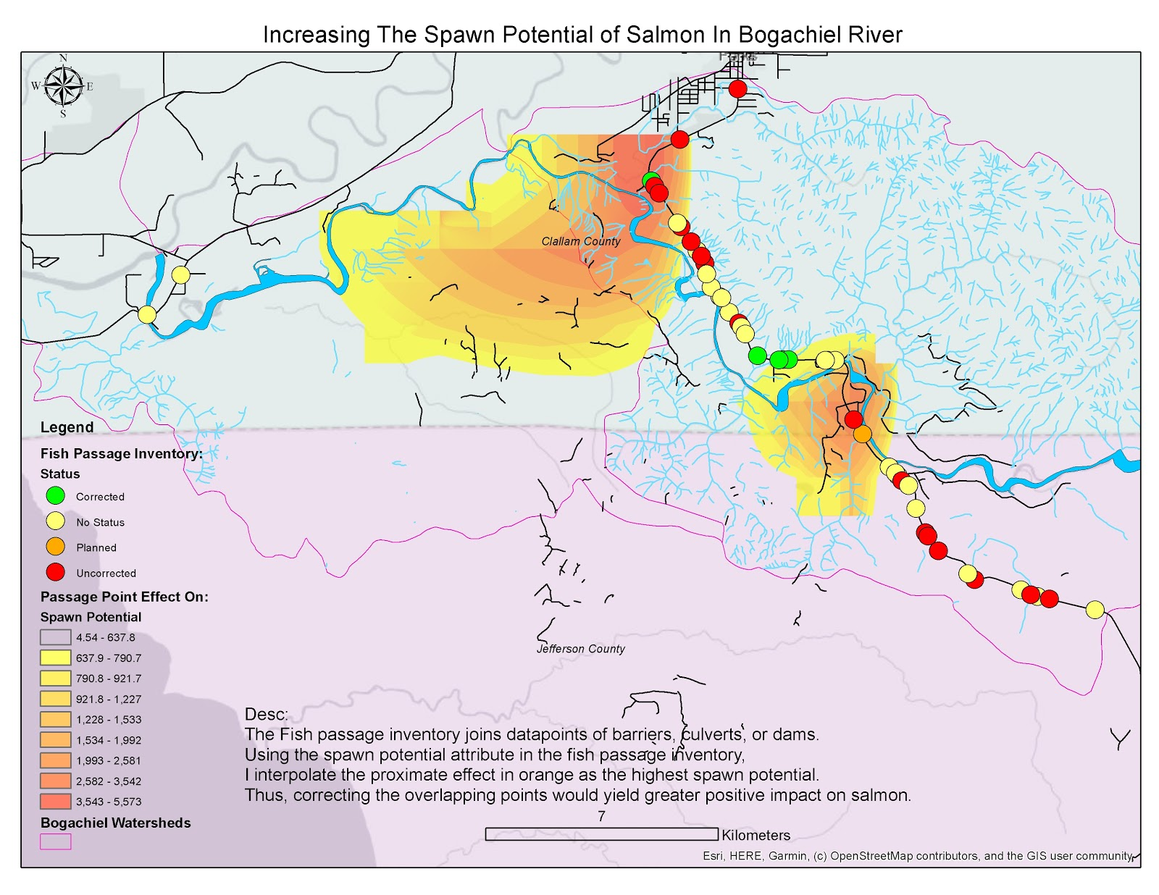

Map 3: Illustrated the likely impact of fish passage correction on fish (including salmon)